Attendance using Face Recognition

Rohit Raj Abhishek Kumar Shah

12011035 (CSE) 12011031 (CSE)

IIIT Sonipat IIIT Sonipat

**CHAPTER I**

1. **INTRODUCTION**

Face recognition is a method of identifying or verifying the identity of an individual using their face. Face recognition systems can be used to identify people in photos, video, or in real-time.

Face recognition systems use computer algorithms to pick out specific, distinctive details about a person's face. These details, such as distance between the eyes or shape of the chin, are then converted into a mathematical representation and compared to data on other faces collected in a face recognition database. The data about a particular face is often called a face template and is distinct from a photograph because it’s designed to only include certain details that can be used to distinguish one face from another.

As a human, our brain is wired to do all of this automatically and instantly. In fact, humans are toogood at recognizing faces and end up seeing faces in everyday objects. Computers are not capable of this kind of high-level generalization , so we have to teach them how to do each step in this process separately.

Face attendance works by verifying the face against the enrolled face to mark the daily attendance. All you need to do is stand in front of the camera and your face is verified instantly in milliseconds.

1. **OBJECTIVE**

Nowadays more people prefer to do their work electronically. But the process of recording the

student’s attendance is still manual, which is quite slow, inefficient and time consuming.

So, Instead of using the conventional methods i.e. manually taking the records, this proposed system aims to develop an automated system that records the student's attendance by using facial recognition technology. The main objective of this project is to offer system that simplify and automate the process of recording and tracking student’s attendance through face recognition technology. This system can make the attendance marking and management system **efficient, time saving, simple and easy**.

1. **WORKING**

Face recognition is really a series of several related problems:

1. First, look at a picture and find all the faces in it
2. Second, focus on each face and be able to understand that even if a face is turned in a weird direction or in bad lighting, it is still the same person.
3. Third, be able to pick out unique features of the face that you can use to tell it apart from other people— like how big the eyes are, how long the face is, etc.
4. Finally, compare the unique features of that face to all the people you already know to determine the person’s name.

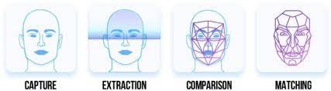

We need to build a *pipeline* where we solve each step of face recognition separately and pass the result of the current step to the next step. In other words, we will chain together several machine learning algorithms:

**Step 1: Finding all the Faces**

The first step is face detection. We need to locate the faces in a photograph before we can try to tell them apart!

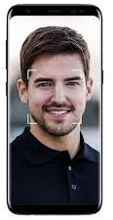

Face detection is a great feature for cameras. When the camera can automatically pick out faces, it can make sure that all the faces are in focus before it takes the picture. But we’ll use it for a different purpose i.e. finding the areas of the image we want to pass on to the next step in our pipeline.

In this process we encode a picture using the HOG algorithm to create a simplified version of the image. Using this simplified image, find the part of the image that most looks like a generic HOG encoding of a face.

To find faces in this HOG image, all we have to do is find the part of our image that looks the most similar to a known HOG pattern that was extracted from a bunch of other training faces:

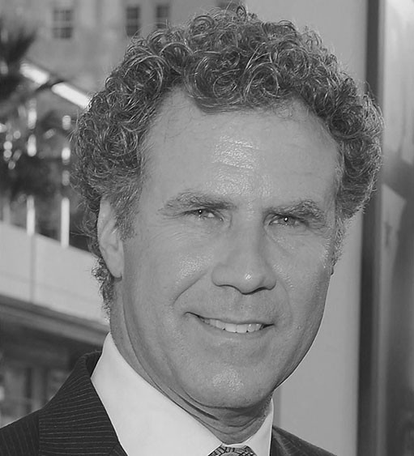

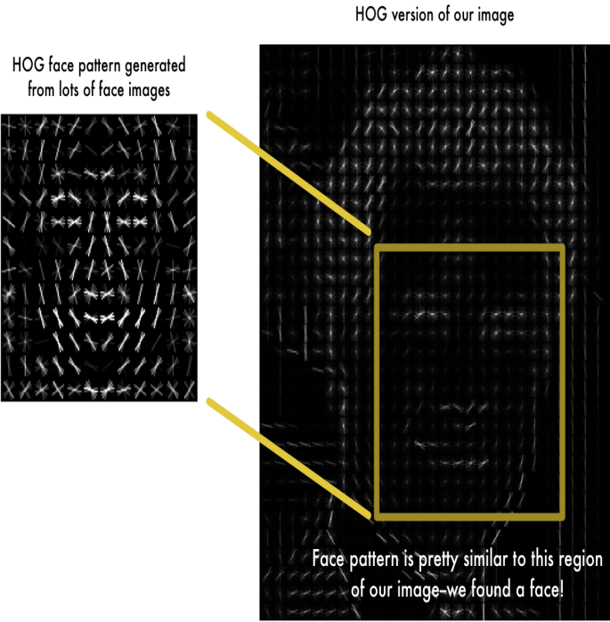

Using this technique, we can now easily find faces in any image.

**Step 2: Posing and Projecting Faces**

Now we have to deal with the problem that faces turned in different directions look totally different to a computer. To account for this, we will try to wrap each picture so that the eyes and lips are always in the sample place in the image. For this, we are going to use an algorithm called **face landmark estimation**.

The basic idea is we will come up with 68 specific points (called landmarks) that exist on every face — the top of the chin, the outside edge of each eye, the inner edge of each eyebrow, etc. Then we will train a machine learning algorithm to be able to find these 68 specific points on any face:

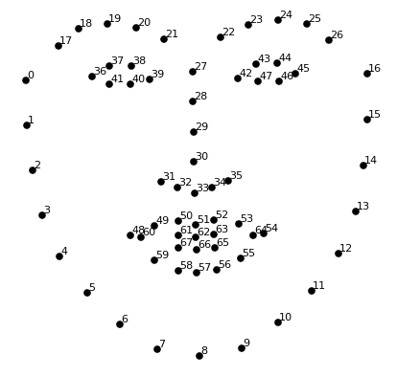

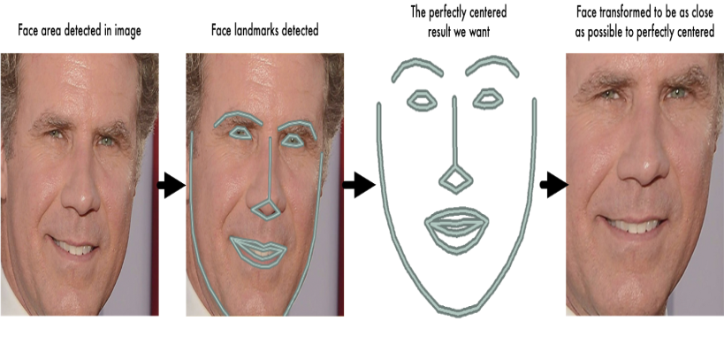

Now no matter how the face is turned, we are able to centre the eyes and mouth are in roughly the same position in the image. This will make our next step a lot more accurate.

**Step 3: Encoding Faces**

In this process we need a way to extract a few basic measurements from each face. Then we could measure our unknown face and find the known face with the closest measurements. The solution is to train a Deep Convolution Neural Network to generate 128 measurements for each face. This 128 measurements of each face is called **embedding**. The training process works by looking at 3 face images at a time:

1. Load a training face image of a known person
2. Load another picture of the same known person
3. Load a picture of a totally different person

Once the network has been trained, it can generate measurements for any face, even ones it has never seen before. All we need to do ourselves is run our face images through their pre-trained network to get the 128 measurements for each face.

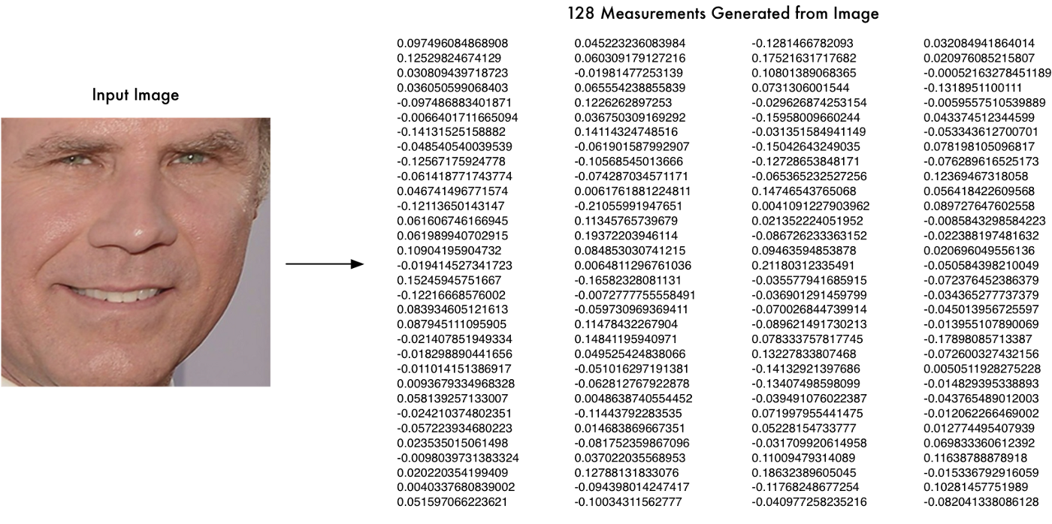

**Step 4: Finding the person’s name from the encoding**

In this step, all we have to do is find the person in our database of known people who has the closest measurements to our test image. All we need to do is train a classifier that can take in the measurements from a new test image and tells which known person is the closest match. Running this classifier takes milliseconds. The result of the classifier is the name of the person.

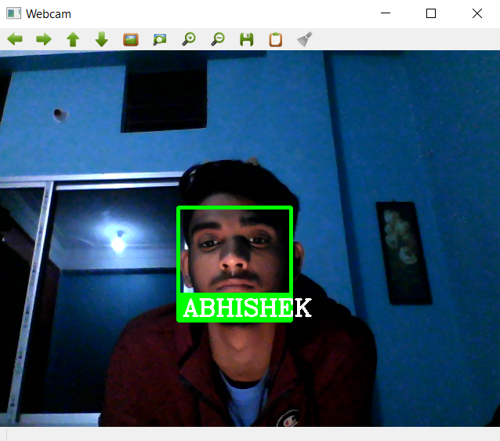

**CHAPTER II**

1. **OBJECTIVE**

We have discussed much about the working of face recognition technology. As the code is now working fine, we will be moving to design a GUI for out application.

GUI is a Graphical Interface that is a visual representation of communication presented to the user for easy interaction with the machine. GUI means Graphical User Interface. It is the common user Interface that includes Graphical representation like buttons and icons, and communication can be performed by interacting with these icons rather than the usual text-based or command-based communication.

What is the need of GUI?

* Simplicity.
* It is visually appealing and makes anyone to get involved in working with the machine.
* Even a guy with no computer knowledge can use the computer and perform basic functions. GUI is responsible for that.

1. **WORKING**

In our project, we have used a cross platform framework “PyQT5 GUI builder” for making a user interface.

PyQt connects the Qt C++ cross-platform framework with the Python language, it is a GUI module.

The principle on which a Qt class functions is related to a slot mechanism responsible for offering communication between items with the purpose of designing re-usable software components with ease.

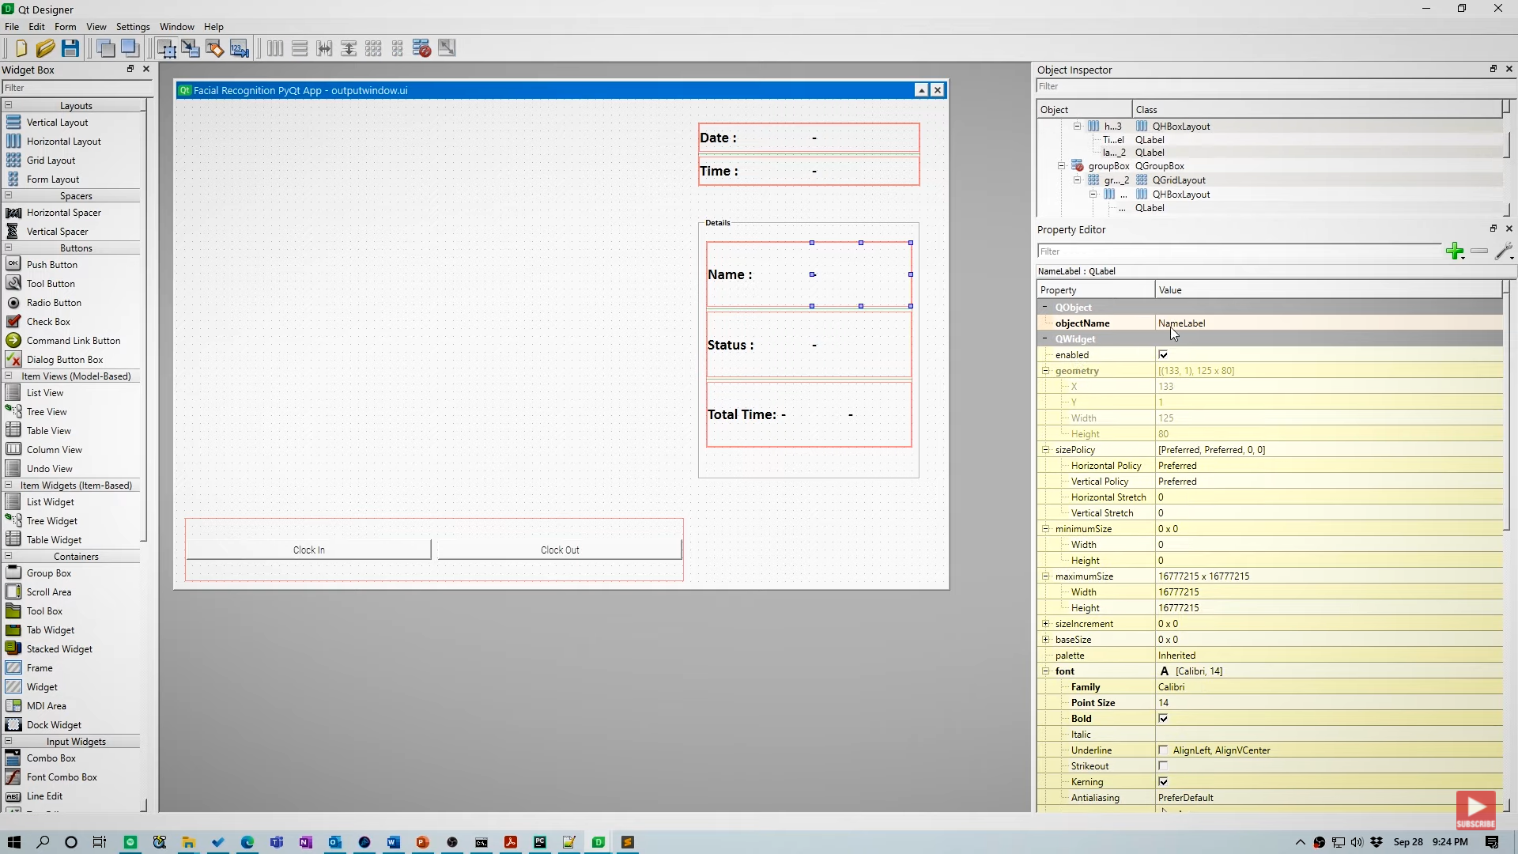

1. **CONCLUSION**

The final output should look something like this.

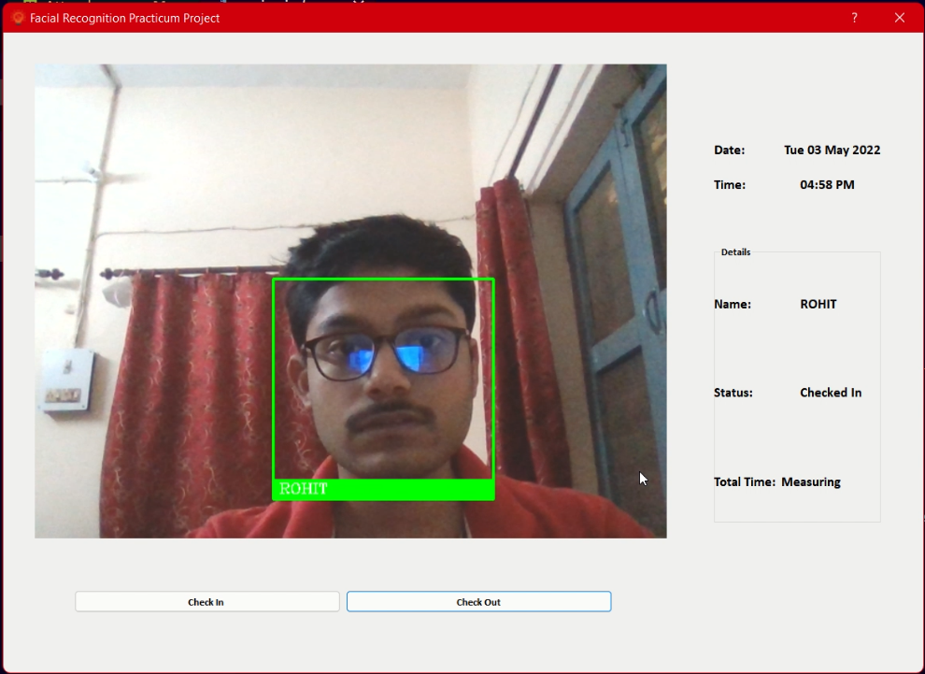

**REFERENCES**

* [Machine Learning is Fun! Part 4: Modern Face Recognition with Deep Learning | by Adam Geitgey | Medium](https://medium.com/@ageitgey/machine-learning-is-fun-part-4-modern-face-recognition-with-deep-learning-c3cffc121d78) – Jul 2016
* <https://www.educba.com/what-is-gui/>
* <https://www.youtube.com/watch?v=cCeUdTXZJHs&t=137s> – May 2020
* <https://www.youtube.com/watch?v=sz25xxF_AVE&t=362s> – Jun 2020
* <https://www.youtube.com/watch?v=oP3MQyO-wwc> – Oct 2020

**PLAGIARISM REPORT**

